網宇實體系統之軟體處理核心設計
Software processing Kernel design of Cyber-Physical Systems
計畫編號：MOST 106-2221-E-194-010
執行期間：106年8月1日 至 107年7月31日
主持人：熊博安 國立中正大學資訊工程學系教授

中文摘要

網宇實體系統(Cyber-Physical Systems, CPS)使得架構得以實現網宇(Cyber)與實體(Physical)之間的跨域優化、即時的巨量資料處理、自我治療(self-healing)等。CPS的系統設計比起傳統嵌入式架構更加多元，例如感測器與雲端之間的整合(second-cloud integration)、異質智慧感測器之整合、可重組式計算架構設計、不確定性處理(uncertainty handling)或預測機制(prediction mechanism)、多模式回饋式控制(multi-modal feedback control)、推論與學習機制(deduction and learning mechanism)等。目前，CPS之設計仍有許多問題未解。例如CPS架構跨界優化之分析平台不夠成熟，巨量異質資料之整合所消耗之時間與運算量過大、缺乏合適於CPS的通訊協定等。本計畫於第一年(104/8~105/7)，基於四種不同的應用領域經驗提出一套CPS之分析平台架構設計。本研究團隊進行四個領域之CPS設計，包含土石流預警、疲勞駕駛預警、智慧電網及智慧交通。分析這幾個應用領域之設計後，歸納出一套比較通用的CPS架構設計，其中主要包含智慧感測層(smart sensor layer)、智慧控制層(smart control layer)和智慧應用層(smart application layer)。本計畫於第二年(105/8~106/7)已進行四個領域的CPS設計實作，包含智慧交通、智慧電網、疲勞駕駛預警、土石流預警。智慧交通CPS中提出適用於低能見度之碰撞警示系統；智慧電網CPS中提出用戶導向之空調優化控制系統；疲勞駕駛CPS中提出基於心率變異度數據之駕駛員疲勞偵測和預測系統；土石流預警CPS中提出具模式切換之土石流預警CPS設計。第一年所提出之架構設計已於第二年實作於四種不同的應用領域並且實驗結果顯示可有效解決上述的以下問題：降低感測之時空需求、資料面的不確定性處理、跨界優化之通用方法及預警與推論學習方法之整合。本計畫於第三年(106/8~107/7)設計各種核心(Kernel)，以異質資料融合為核心、以強化學習為核心、以數據重組為核心以及以異常分類為核心。並將各式核心應用於本計畫所應用的領域當中。

關鍵詞：網宇實體系統、感測雲整合、架構設計、不確定性處理、預警、推論與學習、模型導向預測控制

Abstract
Cyber-Physical Systems (CPS) enables the architecture to achieve cross-domain optimization between cyber and physical, instant massive data processing, and self-healing [system]. The architecture of CPS is also more variant than that in the embedded systems, due to sensor-cloud integration, multiple smart sensor integration, reconfigurable computing design, uncertainty handling via prediction mechanism, multi-modal feedback control, and deduction and learning mechanism. There are still several open problems in the CPS design, for example, common artifacts of CPS architecture design have not yet been identified and analyzed, immature cross-domain optimization and analysis platform, large consumption of time and power in heterogeneous data integration, and also lack of communication protocols for CPS.
In the first year (2015/8~2016/7) of this project, based on our design experiences in four different application domains, we proposed the design of a platform for CPS design and analysis. Our research team were involved in the CPS design for the following four application domains, including smart traffic, smart grid, driver fatigue prediction, and landslide prediction. After analyzing the four CPS applications, a generic CPS architecture was proposed, which includes smart sensor layer, smart control layer, and smart application layer. In the second year (2016/8~2017/7) of this project, we implemented the CPS architecture proposed in the first year. The architecture proposed in the first year has been applied to the above four application domains, and experiment results show that the following problems were solved. The time/power consumption of sensing, the uncertainty handling for data, generic method for cross-domain optimization including the integration of prediction and deduction with learning mechanisms have been solved. In the third year (2017/8~2018/7), the project designed various kernels. They are heterogeneous data fusion, reinforcement learning, data reorganization, and exception classification as the kernels. All of them have been applied to the field of applications in this project.

Keywords: cyber-physical systems, sensor-cloud integration, architecture design, uncertainty handling, prediction, deduction and learning, model predictive control

- Research goal:
The main goal of this project is to propose the generic architecture of the Cyber Physical System (CPS). Due to the wide range of applications and heterogeneity of CPS, system designers have felt that it has been extremely difficult to accumulate cross-domain design experience over the past few years. Therefore, in the new field, almost new ways of using it have been invented.

The project is divided into three years of implementation, from 104 to July 107. The goal of the first year of the project is based on the team's past CPS design experience in four different application areas, and a set of universal design platforms that can be reused in different application areas. In the second year, the project aims to achieve the universal design platform proposed in the first year in four different application areas, and to confirm whether it is feasible and to analyze its benefits. In the third year, we formally proposed and designed the main processing kernels of CPS. Therefore, in this third year’s report we will present the kernels of our design and apply the kernels of the design to the four areas of the programs.

- Research methods and results
Our research team have been extensively involved in CPS system design experience in four different application areas. Four processing kernels have been proposed in the area of heterogeneous data fusion, reinforcement learning, data reorganization and anomaly classification, and harness them as the kernels of the application. Applications that exploit these kernels are landslide prediction, driver fatigue prediction, smart grid and smart traffic. Research methods, mainly adopting kernel-based strategies. After designing the processing kernel, team members use this in different applications, such as reinforcement learning as the kernel for smart traffic. In this report, we will explain how we applied the processing kernel to the four applications of the project and at the same time, we also explain the experimental and analytical results of each system design and its implementation.

- 數據重組核心 -- 基於深度神經網路重建數據於土石流感測(Deep Neural Network-based Data Reconstruction for Landslide Detection)

Landslides could cause huge threats to lives and cause property damages. In the landslide prediction system, environmental information can be collected through sensors to detect the possibility of landslide occurrences. However, the data collected by wireless sensor network systems (WSNs) may be lost due to sensor failures, external interferences or other environmental factors, which may affect the accuracy of landslide predictions.

In order to solve the problem of missing data, a data reconstruction method based on rainfall intensity, soil moisture, slope, and slope direction, also reconstructs missing data based on heterogeneous data and temporal and spatial relationships was proposed. In terms of spatial, in addition to considering the distance between the sensing nodes, the terrain of the area (such as slope and slope direction) and the area of rainfall are also considered. In terms of temporal, it is based on the data trend of the past period of time as a data reconstruction consideration, and combined with the correlation between heterogeneous data (such as rainfall and soil moisture).

- Deep Neural Network-based Data Reconstruction System Architecture
In this section, we briefly introduce our method called Spatio-Temporal Heterogeneous Data Reconstruction System (STHDRS). Figure 1 shows the basic framework of our method. The description of our proposed architecture is as follows.
The system architecture consists of two parts, Physical Entities and Computing Elements. In the Physical Entity, we collect environmental data through sensor nodes. Environmental data include soil moisture, rainfall intensity, slope direction and slope. The sensed data received from sensor nodes are finally integrated by the coordinator and transmitted to the Computation Elements. The Computation Elements contains Loss Identification Module, Data Preprocessing Module, Deep Neural Network-based Data Predication Module, Data Compensation Module and Historical Data.
Fig. 1. Deep Neural Network-based Data Reconstruction System Architecture

- Loss Identification Module
The module detects whether the currently received environmental sensing data is missing. If the module detects that the data is missing, it records the time and location of the missing data, and if the data is normal, it is stored directly to the historical database.
- Data Preprocessing Module
The task of this module is to normalize the data. It integrates four heterogeneous environmental data into a unified data format.
- Deep Neural Network-based Data Prediction Module
The module reviews the temporal and spatial relationships of heterogeneous data to learn the characteristics of the environment, and predicts the future environmental data based on historical environmental data.
- Data Compensation Module
This module is used to fill missing data. When a data loss is detected, the module will use the data predicted for the current time slot using history data to fill in the missing data.

- Historical Data
The data reconstruction system needs to use historical data to predict the reconstruction data. Historical data contains four kinds of heterogeneous data namely soil moisture, rainfall intensity, slope direction and slope.
(b) ConvLSTM prediction model framework design

Fig. 2. ConvLSTM prediction model framework design

The system flow chart is shown in Figure 2. First, the computing elements receives the data sent by the environmental sensor from the physical entities, and the Loss Identification Module will determine whether there is data loss. If the data is not loss, the data is stored in the historical database. Otherwise, the time of the data and the location of the lost data are recorded. The historical data used to estimate the current time slot data value are normalized by the Data Preprocessing Module. Then, the trained Deep Neural Network-based Data Prediction Module is used to estimate the data value of the current time slot using historical data. Then, the Data Compensation Module will find the estimated data value of the missing location and compensate it to the lost area. Finally, the reconstructed data is stored in the Historical Data.

(c) Experimental result and analysis
First, the experimental setup and dataset used for experiments are introduced. Then, the experimental results are illustrated (d). The experimental environment and the environment data used in our experiments are described as follows.

- Experimental Environment
As shown in Table 1, the proposed method is implemented in the Python programming language version 3.6.4 on a server with Intel(R) Xeon(R) CPU E5-2620 0 @ 2.00GHz, NVIDIA GTX1060 6G, 16 GB RAM running Ubuntu 16.04.4 LTS (Xenial Xerus) (64-bit) OS. The Python programming language is used for realizing the proposed Spatio-Temporal Heterogeneous Data Reconstruction System (STHDRS).

Table 1. Hardware and Software used for experiments

- Dataset
The soil moisture and rainfall intensity data from the historical environment monitoring datasets used in this experiments are from the Soil and Water Conservation Bureau, Council of Agriculture, of Taiwan. The time interval of the rainfall intensity and soil moisture data is five minutes. The slope direction and slope rank data are from the National Land Surveying and Mapping Center (NLSC), Taiwan. Sensor nodes are deployed in a grid of size 20 x 20 and the distance between each sensors is 2 km. The data used in this work were collected during the time period from April 5, 2013 to October 12, 2017 and there were 22,500 samples of data, which were used for training the ConvLSTM model and 2,250 samples were used for testing. The data were collected from the Shen-Mu, Shang-An, Jun-Keng, Feng-Qiu, Hua-Shan, Feng-Shan and Ping-Ding stations.

Two data reconstructions experiments, Soil Moisture and Rainfall, have been conducted. There are also three types of missing data, Random, Gradual Fading, and Spatial Event. Figure 3 shown our experimental result from Soil Moisture with Random missing. The reconstruction results are analyzed using root mean square error. Table 2 and Table 3 represent our experiment results.

Fig. 3. Comparing Different Reconstruction methods for 20% Missing Rate Random Missing Soil Moisture Data

Table 2. Rainfall Reconstruction RMSE in Random Missing Data Type

Table 3. Soil Moisture Reconstruction RMSE in Random Missing Data Type

In the first and second experiments, we reconstruct Rainfall and Soil Moisture data in Random Missing data type, and calculate the RMSE for each missing rate. As shown in Table 2 and Table 3, the performance of linear interpolation method is the worst, while the other two deep learning methods can learn the trend of historical data so the reconstruction results are better. Comparing with different reconstruction methods for Random Missing rainfall data, ConvLSTM method performance is the best.

Comparing Table 2 with Table 3, since the Rainfall data are 0 for most of the time, the calculated rainfall RMSE is lower than the RMSE of the soil moisture. As shown in Figure 3, we can see that the Soil Moisture data reconstructed by our proposed method is closer to the original data.

(d) conclusion
We proposed a Spatial-Temporal Heterogeneous Data Reconstruction system (STHDRS) for landslide detection. We consider spatial and temporal characteristics of data to reconstruct missing data. It used heterogeneous data, such as soil moisture, rainfall intensity, slope direction and slope rank to reconstruct missing data. The RMSE of our reconstruction are less than other reconstruction methods in all of missing data type. Even if the data loss rate is as high as 90%, the data reconstructed by our method which RMSE of FS can still be less than 0.3

2.強化學習核心 － 基於深度強化學習之自動駕駛車兩路口控制系統(Deep Reinforcement Learning-based Autonomous Intersection Management)

Road accidents at intersection significantly impact traffic flow and account for a significant proportion of all accidents. With the trend of increasing population and vehicle numbers, it is necessary to develop a safer and more efficient intersection control system. Furthermore, with the advancement of vehicular communication and self-driving technology, we can develop a smarter control system that can reduce the traffic accidents caused by human factors.
For increasing safety and efficiency of traffic environment, we propose a Deep Reinforcement Learning-based Autonomous Intersection Management (DRLAIM) system. This method contains three main models, including brake-safe control model, intersection control model based on reinforcement learning and priority assignment model. We train the system to learn a good intersection control policy by interacting with traffic environment through reinforcement learning and the brake-safe control model is used to ensure the safety of each autonomous vehicle during travel.
Experiment results show that after training using reinforcement learning, the throughput of intersection control model increased by 83%. In comparison with the Fast First Service (FFS) policy, the average waiting time of DRLAIM reduced by about 1.2% to 11.4%

- Deep Reinforcement Learning based Autonomous Intersection Management System Architecture
Figure 4.1 shows the basic framework of our method as proposed in this Thesis. DRLAIM consists of two parts including vehicle and intersection controller. the vehicle part, the brake-safe control model guarantees the vehicle remains in the brake-safe state where it can always safely brake without colliding with other vehicles with higher priorities. While a vehicle enters the cooperative zone, it starts to send a request to the intersection controller to ask for a priority to pass the intersection. A vehicle needs to wait in front of the stop line until it receives a priority from the confirm message sent by the intersection controller, then it can cross the intersection according to its priority value.
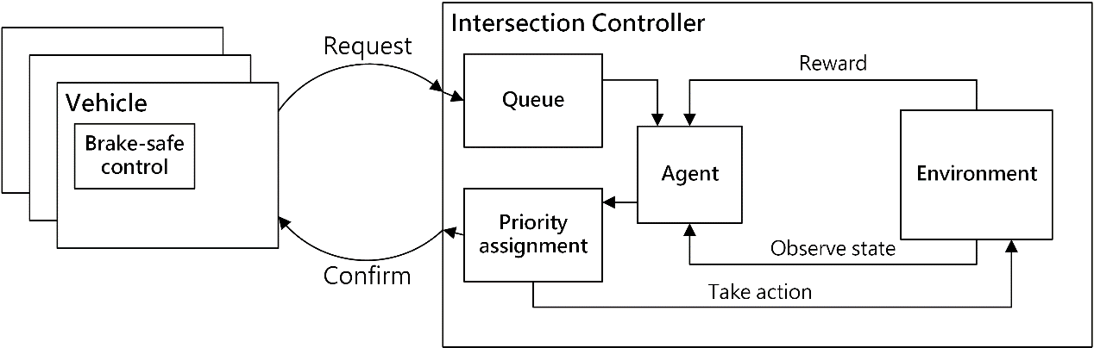
Figure 4.1: Deep Reinforcement Learning based Autonomous Intersection Management System Architecture
- Deep Reinforcement Learning based Autonomous Intersection Management System Flow Chart
In the intersection controller, it consists of four parts including queue, environment, priority assignment model and agent. The queue is designed with n sub-queues, one for each lane, where n is the total number of incoming lanes at a particular intersection. The queue architecture is illustrated in Figure 4.2 where each sub-queues stores the vehicle ID of vehicles and the time that the queue received this request in the corresponding lane. Once a request is confirmed, the corresponding request consisting of vehicle ID and timestamp will be removed from the queue. The environment part monitors the state of traffic environment that consists of queue size, average waiting time of vehicles and number of vehicles inside the intersection. The agent is responsible for choosing an action which allows vehicles to pass an intersection. At every time step t, the agent observes the state $s_{t}$ from environment, and chooses an action $a_{t}$ which allows vehicles to pass. Then the agent sends the action $a_{t}$ and corresponding requests from queue to the priority assignment model to execute the action $a_{t}$. After executing the action, the
state of the environment transits to $s_{t+1}$ and the agent receives a reward $r_{t+1}$. The goal of an agent is to develop an optimal policy to maximize the cumulative reward
$\sum_{t}{r_{t+1}}$.After the priority assignment model receives an action $a_{t}$ and corresponding requests, it will append the corresponding vehicles to priority list that stores priority relations among vehicles one by one. The priority assignment model then sends
confirm messages and priority list to corresponding vehicles.
Figure 4.6 shows the flow of how intersection control works.

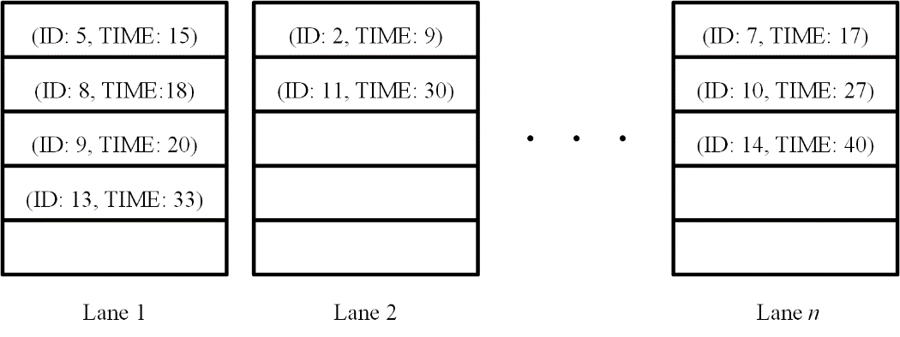
Figure 4.2: The architecture of queue
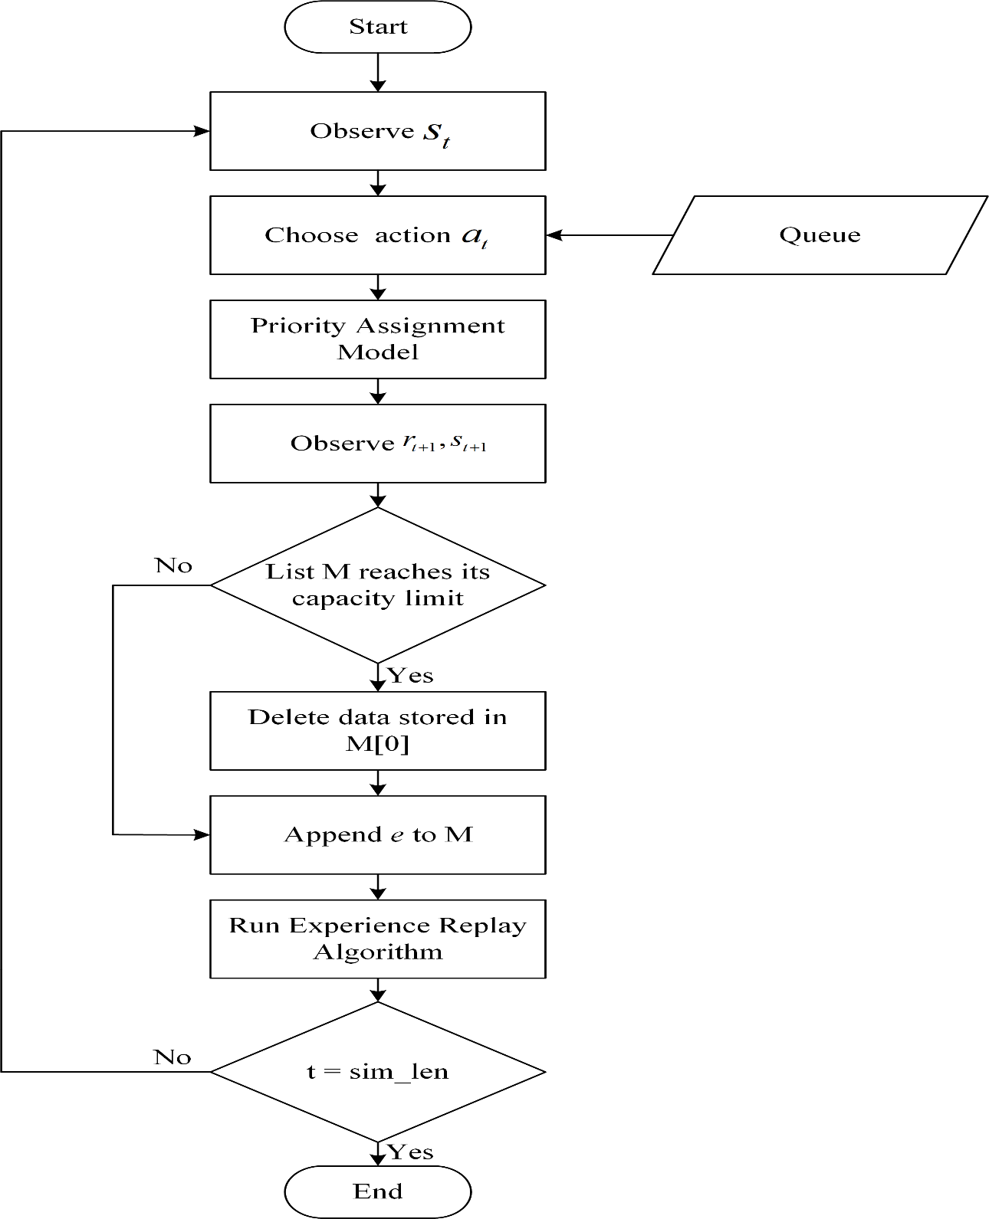
Figure 4.6: Flow of intersection control policy

- Deep Reinforcement Learning based Autonomous Intersection Management Experimental Results
As shown in Table 5.1, our method is implemented in the Python programming language on a PC with Intel(R) Core(TM) i7-6700 3.4 GHz CPU, 24 GB RAM running Windows 10 (64-bit). The Python programming language is used for realizing the proposed Deep Reinforcement Learning Autonomous Intersection Management (DRLAIM) method.

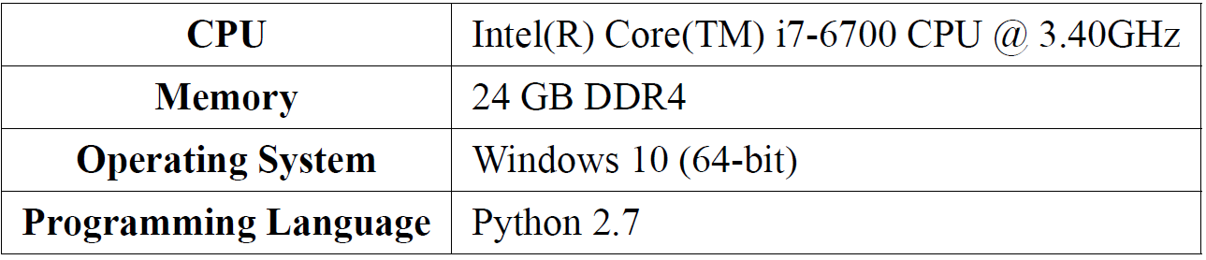
Table 5.1: Experimental environment

The testing platform used in our experiment is a simulator called Simulation of Urban Mobility (SUMO).
We have implemented and integrated the proposed DRLAIM framework into
SUMO. Figure 5.1 shows the intersection model used in our experiments which consists of 12 incoming lanes. The vehicles in the leftmost lane can only turn left, those in the middle lane can only go straight and those in the rightmost lane can either go straight or turn right. We use an unbalanced traffic flow described by the Origin-Destination (OD) matrix as shown in Table 5.2. The value of 0.2 for the entry (West, East) means that 20% of all vehicles travel from West to East. We use the number of generated vehicles per minute as the parameter for the Poisson distribution to simulate the generation of vehicles. Table 5.3 specifies the parameters used in our experiments.
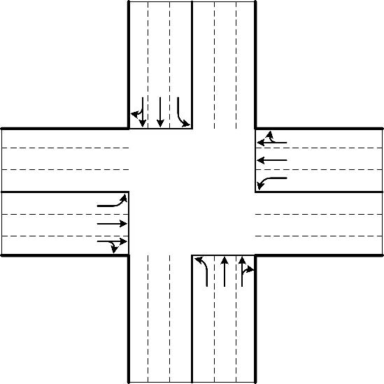
Figure 5.1: Intersection model used in our experiments

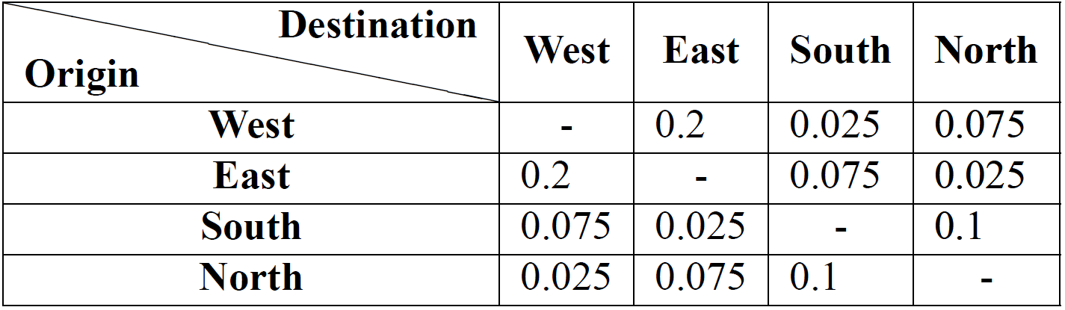
Table 5.2: Origin-Destination matrix

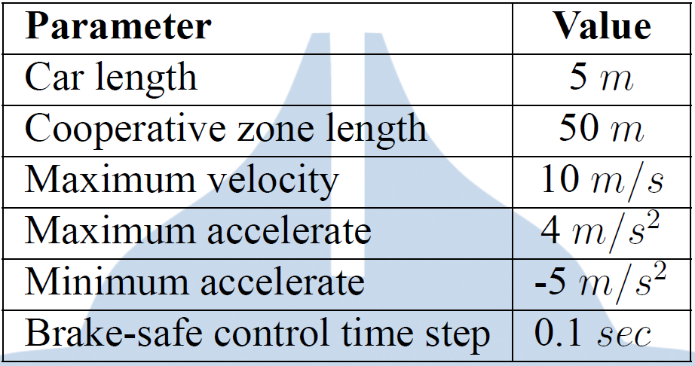
Table 5.3: System parameters
In this experiment, we first evaluate the performance of training results using different combinations of reward functions as shown in Table 5.4. We then evaluate the training results of the reward function with the best performance using different number of training epochs and different action time steps. There are three performance indicators to evaluate the performance of our model: Average Queue Length (AQL), Average Waiting Time (AWT), Throughput.

Table 5.4: Combination of reward functions used for training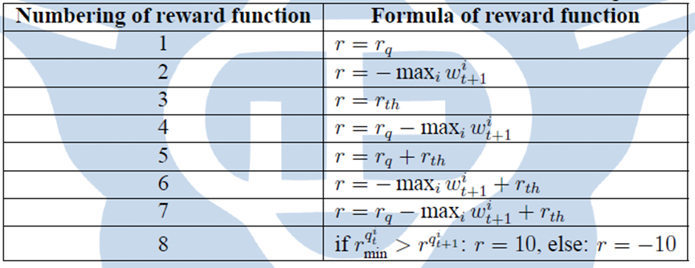

As show in Table 5.6 we can see that the average performance of the last 10 training epochs among the 8 reward functions outperform that of first 10 training epochs which means our DQN model did learn a good policy after training.

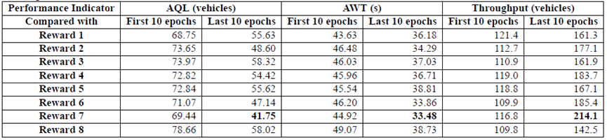
Table 5.6: Comparison of training results between first 10 epochs and last 10 pochs among 8 reward functions

As show in Table 5.7 that the average performance of reward function 7 outperforms other reward functions.
Table 5.7: Average performance difference among 8 reward functions
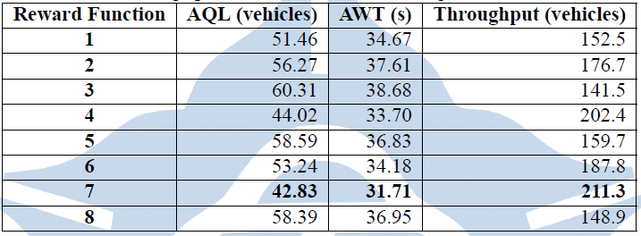
We use reward function 7 to do a further evaluation using different training epochs and different action time steps.
Tables 5.8, 5.9 and 5.10 show the average performance over ten simulations for the models trained with 4 different number of epochs using 3 different action time steps. We can see that the overall performance of trained model using 50 epochs and action time step 0.5 second is the best.

Table 5.8: Average performance of model trained with different number of epochs using action time step 0.2 second
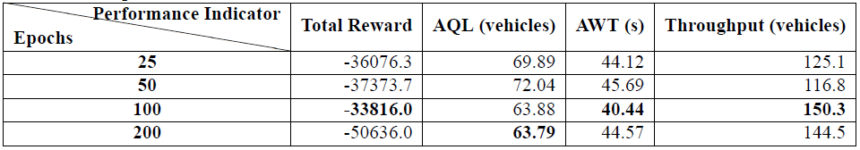

Table 5.9: Average performance of model trained with different number of epochs using action time step 0.5 second
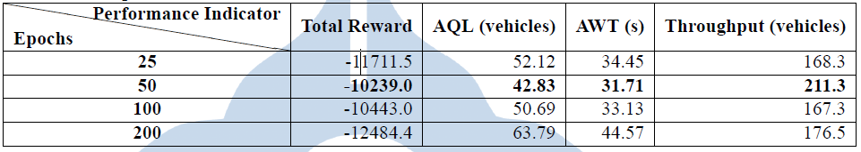
Table 5.10: Average performance of model trained with different number of epochs
using action time step 1 second
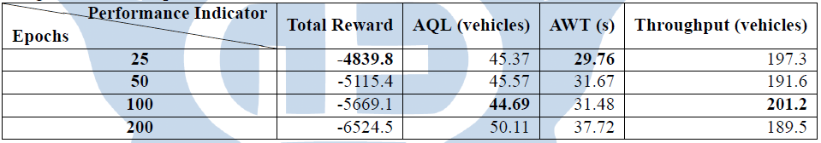

We give the experiment results for our proposed method including the
evaluation of the training results and the comparison with another method called Fast First Service (FFS)
Table 5.11 shows the average performance results. Though the performance of throughput in FFS all outperform DRLAIM, the difference is small. The performance of AWT in DRLAIM outperforms that in FFS except for the low inflow rate of 25 vehicles per minute. We can see that the AWT of DRLAIM is less than that of FFS (reduced from 1.2% to 11.4%) except for the low inflow rate of 25 vehicles per minute. We believe that the reduction in AWT by DRLAIM is because of the consideration of waiting time in the design of the proposed reward function, which leads to a much fair action selection policy.

Table 5.11: The result of the average performance over ten simulations using 4 different inflow rate
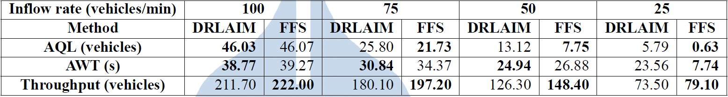

- Deep Reinforcement Learning based Autonomous Intersection Management conclusions
We proposed a Deep Reinforcement Learning-based Autonomous Intersection
Management (DRLAIM) system to learn an intersection crossing policy. In DRLAIM, the brake-safe control model [6] determines the accelerate control of all vehicles that guarantees safety by avoiding collision. The intersection scheduling model based on deep reinforcement learning develops an action selection policy to determine an incoming lane from where vehicles can pass an intersection by observing and interacting with the traffic environment. We have tested 8 different reward functions and the experiment results show that the throughput of intersection control model with reward function 7 increased by 83%. In the comparison with the FFS policy, the average performance of AWT in DRLAIM reduced by 1.2% to 11.4%. Furthermore, though we consider the waiting time in the design of the proposed reward function 7 to learn a fair action selection policy, the difference of average performance of throughput between DRLAIM and FFS is tiny.

3. 異常分類核心 – 智慧變電所基於深度學習異常偵測(Anomaly Prediction in Smart Substation with Deep Learning)

Traditional electric networks usually have four operations, including electricity generation, electricity transmission, electricity distribution, and electricity control.
Electricity is generated from power generators such as nuclear plants, oil plants, or coal plants and transmitted to users via power lines. In case there is a failure event in electricity transmission, a large number of users will be affected. If we can predict such anomaly, we can reduce the loss of power supplier and reduce the number of affected electricity consumers.
The proposed system includes a prediction model that predicts the future electricity grid situation and the occurrence of anomaly. According to the predicted results, the management system will warn the members in the grid so as to reduce the number of affected electricity consumers.

Method
The Smart Substation Anomaly Prediction System contains the following modules:
data collect module
The module collects the information of power transmit, including power-generatorto-substation, substation-to-micro-grid, and micro-grid-to-micro-grid.
real time abnormal detect module
This module detects anomalies. It tries to reset the power generator or uses the Imbalanced
Data Over-Sampling Module to preprocess data. The specific methods will be described in Section 4.1.

imbalanced data over-sampling module
The abnormal situation only account for a small part of the whole time. It will make the learning module mistaken for noise. So that, we have to do some preprocessing before learning.
LSTM learning module
The module reviews historical data to learn the characteristics of the power transmission, and predicts the future transmission data. The specific methods will be described in Section 2.
early warning module
This module broadcasts the predicted results to the power generator and microgrids. The specific methods will be described in Section 3.
power generator control module
This module controls the power generator, including informing the required power in the next few time slots, controlling the breaker of power generator, and resetting the power generator.
micro-grids command module
This module broadcasts the command from the real time abnormal detect module and the early warning module to micro-grids, including disconnecting all microgrids, allowing micro-grids to connect, and pre-informing anomalies.
History data
The learning model uses historical data to make predictions. Historical data includes the state of the generator, the time of power transmission, the ID of the transmit unit, the real power of the power transmission, voltage and phase.

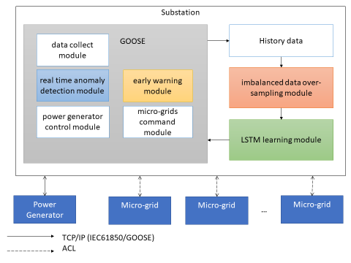

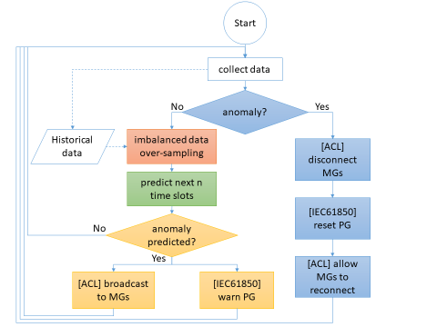
The system flow chart is shown in Figure 4.2. First, the Data Collect Module gets the 21 real time data, and the Real Time Anomaly Detection Module will detect if any anomaly
has occurred. If an anomaly has occurred, it tries to reset the power generator. If the situation is normal, it uses the Imbalanced Data Over-Sampling Module to preprocess the data. Then, it uses the LSTM Learning Module to predict if there will be anomalies in next few time slots. If an anomaly is predicted, the Early Warning Module uses the
Power Generator Control Module and the Micro-Grids Command Module to broadcast the results.
Next, we will introduce the methodologies for the Real Time Abnormal Detect Module, the Imbalanced Data Over-Sampling Module, the LSTM Learning Module, and the Early Warning Module in details.

The imbalance data over-sampling module preprocesses the data before learning.
Since a normal system works fine most of the time, it means we will collect lots of normal data and only little anomaly data.

Results Analysis
we compare different over-sampling methods and use Receiver Operating Characteristic curve (ROC curve) to illustrate the diagnostic ability of a binary classifier system

Using the above four types, we can calculate the True Positive Rate (TPR), False Positive Rate (FPR), and Accuracy (ACC), which help to analyze the effects of the target binary classifier system.

we find out through experiments the parameter values that are most suitable for the Learning model. We will determine the number of layers in the learning model, the dimensions of the hidden layer, and the number of time slots to reference when predicting.
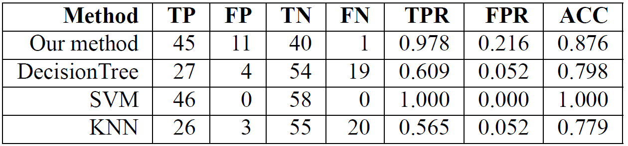
we compare different types of classifier and the comparison results are as shown in Table, where we can see the effect of common classifier. The decision tree method and KNN method got about 20 on FN, means these two methods can not effectively classify our dataset. The SVM method have the best TPR, the lowest FPR, and 100% accuracy, SVM is a very good linear classifier, we think it is because the data set is too simple, and we divide the normal data and anomaly data by simple linear combination, the method is too similar to the SVM method, so that SVM can get such high accuracy in our experiment.

An anomaly detection system for smart substations where deep learning was used to detect anomalies and predict the power consumption and the power generated based on history data. We improve the accuracy by using a LSTM learning model to predict the ower consumption and the power generated because LSTM can have better accuracy than other common anomaly detect methods

4. 異質資料融合核心– 異質傳感資料基於深度學習的疲勞駕駛預測(Driver Fatigue Prediction using Heterogeneous Sensor Data with Deep Learning)
Fatigue driving is one of the main causes of traffic accidents. If we can predict that a driver will be fatigued in the near future, and give warnings and parking suggestions to let the driver stop and rest, traffic accidents can be reduced effectively.
In the past, most research work on fatigue driving used data from a single sensor. Once the sensor is faulty, the accuracy of the prediction system will be affected and it might even go unoperational. In addition, past research on driver fatigue prediction mainly used the conventional Back Propagation Neural Network (BPNN) model to make predictions. However, a driver’s fatigue can usually be represented by a time series of sequence data. BPNN could not co-relate sequential instances of data in that series, thus making predictions not so accurate.
We propose a system that not only uses data from multiple heterogeneous types of sensors, but also are the more effective Recurrent Neural Network(RNN) with Long Short-term Memory (LSTM) building blocks to predict driver fatigue. We use the Heart Rate Variability (HRV) and the Percentage of Eyelid Closure(PERCLOS) simultaneously as data input to the LSTM RNN model so as to predict whether the driver will be fatigued in some future time slot. Thus, drivers are given timely warnings and or parking suggestions.

(a) Driver Fatigue Prediction Monitoring System Architecture
The proposed architecture for Driver Fatigue Prediction Monitoring System is shown in Figure. The system can be divided into two layers. The first layer is the Physical Layer, which is responsible for obtaining a driver’s pulse wave signal and processing the signal to get data features. The second layer is the Cyber Layer which is responsible for analyzing and predicting fatigue.
Fig：Driver Fatigue Prediction Monitoring System Architecture

First layer is Physical Layer, contains the following modules：
- Eye Image Sensor Device/Heart Rate Sensor Device
The task of this part is doing the raw data collected. We use camera to collect eye image data, and use pulse sensor to collect heart rate data.

- Heart Rate Signal Processor
Responsible for converting the driver's heart rate signal into Heart Rate Variability (HRV) data and extracting feature values for use by the Cyber Layer. In this study, we used a pulse sensor device to collect the pulse signal of the driver and calculated the Heart Rate Value (HRV) value in the Signal process. HRV is a measure of the degree of change in the continuous heart rate.
It is mainly obtained by analyzing the time series of heartbeat and heartbeat intervals obtained by analyzing the pulse. After obtaining the HRV data, basic signal processing will be performed, that is, the time domain and frequency domain analysis of the HRV data will be performed, and the SDNN (Standard Deviation of Normal to Normal), RMSSD (root mean square of successive differences), Low Four parameters, which are representative of fatigue, such as Frequency (LF) and High Frequency (HF), are used as eigenvalues for analysis.
- Eye Image Signal Processor
First, each original eye image is converted into a gray scale image. Second, the threshold for binarising is defined by the gray scale image. We convert the gray scale image into a histogram, and calculate the total number of each pixel between 0 to 256,and chose the max number of all pixels as the binarized threshold. Third, convert the picture into only black and white pixels by the threshold. According to P80, if there are over 80 percent white pixels in one image, the image is regarded as closed. On the contrary, the image is regarded as open if there are less than 80 percent white pixels. After processing one minute of frames, the driver's state is defined as awake or fatigued for one time slot.

The second layer Cyber Layer is composed of the following modules：
- Driver Fatigue Detection Module
Because the original preprocessed HRV data (RMSSD,SDNN,VLF,LF,HF) would being different from person to person, we choose three reliable ratios as driver fatigue detection data, which are RMSSD/SDNN, LF/HF, VLF/HF [35].
After collecting enough time slot of heterogeneous sensor data, we organize al ldata into four-stream time series data, which are RMSSD/SDNN, LF/HF, VLF/HF, and PERCLOS. Each stream is com posed by one hour collected data.
To label driver fatigue state as awake or fatigue for each time slot, we ask the driver about his or her feeling for each time slot. Combine the four-stream data state with driver feeling, we make a voting to decide the driver fatigue state of each time slot. The voting flow is shown as in Figure . The four-stream preprocessed data and the label will be the input of driver fatigue prediction module.

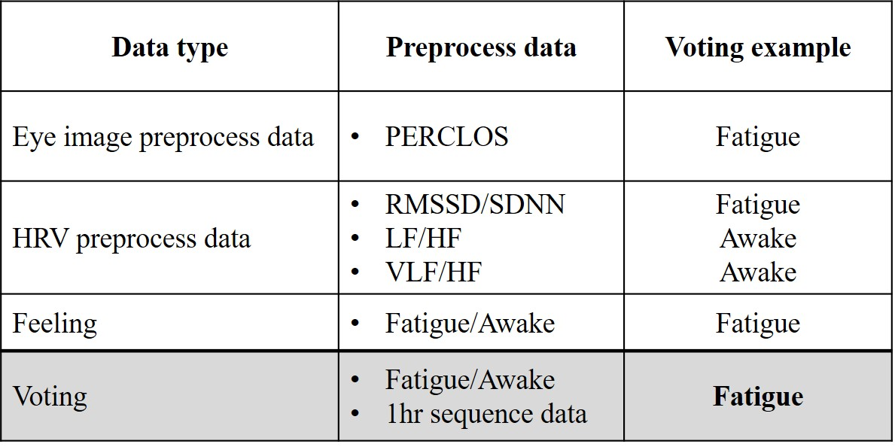
Fig: Voting Flow for Labelling Data
- Driver Fatigue Prediction Module
Although the information on fatigue driving is time-sequential, the earlier information may not have much effect on the later information. For example, the fatigue data before one hour may not be related to whether the driving is tired after one hour.
Therefore, we use long short-term memory (LSTM) to design the driver fatigue prediction module. LSTM is composed of one input layer, one recurrent hidden layer that is a memory block, and one output layer. Each memory block is composed of a cell, an input gate, an output gate and a forget gate[1]. The three gates provide continuous analogues of write, read and reset operations on the block. Through multiplicative gates, each gate can learn to open and close, and thus LSTM memory cells can store and access information over long periods of time, and as a result mitigating the vanishing gradient problem.
The module structure is shown as Figure . Each input layer consists of four streams of data input. After training, output the four streams of predicted data for the next time slot.

Fig: Driver Fatigue Prediction Module Design Structure

- History Data
The task of this part is to restore the analyzed data we got from Fatigue Detection
Module for training data of the Driver Fatigue Prediction Module.。
(b) Driver Fatigue Monitoring System Flow Chart
The system flow chart is shown in Figure . First, the camera captures the eye image, while the pulse sensor collects heart rate data. After the pulse sensor collects 256 data samples, and the camera collects data samples in one time slot, the heart rate data are preprocessed, and time domain and frequency domain analysis are performed.
At the same time, the PERCLOS for eye image data are calculated. After preprocessing HRV and eye image data, the system organizes all the preprocessed data of HRV and eye image into four streams time series data.
After the system has collected enough time series data, the system detects driver fatigue and labels each time slot data as awake or fatigue. The time series of preprocessed data are then input to the driver fatigue prediction module. After prediction, the system gives the driver a warning or parking suggestion.
Fig：Driver Fatigue Monitoring System Flow Chart

(c) Driver Fatigue Monitoring System Experimental Results
The eye image data and the heart rate data of a 23 years old healthy female subject and a 22 years old healthy male subject were recorded. The subjects are asked to watch a driving video to simulate they were driving a car for 1hour. While they were watching, the heart rate data were collected with the SEN-11574 sensor and the eye image data with the camera Logitech C-615. The subjects were initially quite awake and gradually got fatigued. (1) We obtain 12 sets of data from quite awake to fatigue. A total of 873 data samples are used to train the Driver Fatigue Prediction Module. (2) We obtain 2 sets of data from quite awake to fatigue. A total of 153 data samples are used to test the Driver Fatigue Prediction Module. Experiment environment is shown in Table.
Table: Experiment environment
Item | Type
CPU | Intel(R) Core(TM) i7-3770 CPU @ 3.40GHz
Memory | 12 GB RAM
Operating System | Windows 10 (64-bit)
Single-board microcontroller | ATMEGA2560
Pulse Sensor | SEN-11574
Camera | Logitech C-615
Programming Language | Python 3.6, Arduino

We use the above metrics including RMSE, Error rate, TPR, FPR, and accuracy to assess the Driver Fatigue Prediction Monitoring system.。The Abbreviations of Each Module is shown in Table. HPL is our module.

Table: The Abbreviations of Each Module
HB | Single sensor data (HRV) with BPNN-based driver fatigue prediction module
PB | Single sensor data (PERCLOS) with BPNN-based driver fatigue prediction module
HPB | Heterogeneous sensor data with BPNN-based driver fatigue prediction module
HL | Heterogeneous sensor data with BPNN-based driver fatigue prediction module
PL | Single sensor data (PERCLOS) with LSTM-based driver fatigue prediction module
HPL | Heterogeneous sensor data with LSTM-based driver fatigue prediction module

As shown in Table, Table and Table, the overall accuracy in predictions of HL has the best performance in all types of modules, the predition TPR and the Accuracy of HL are respectively 89% and 90%

Table: Comparison of the Heterogeneous Sensor Data + LSTM-Based Prediction Module (HL) with the Single Sensor Data (HRV/PERCLOS) + BPNN-Based Prediction Module (SHB/SPB)

 | RMSE | Error rate | TP | FP | TN | FN | TPR | FPR | Accuracy
SHB | 0.3791 | 38% | 40 | 12 | 91 | 10 | 80% | 11% | 85%
SPB | 0.3429 | 34% | 29 | 0 | 106 | 18 | 61% | 0% | 88%
HL | 0.183 | 18% | 51 | 8 | 88 | 6 | 89% | 8% | 90%

Table: Comparison of the Heterogeneous Sensor Data + LSTM-Based Prediction Module (HL) with the Heterogeneous Sensor Data + BPNN-Based Prediction Module (HB)

 | RMSE | Error rate | TP | FP | TN | FN | TPR | FPR | Accuracy
HB | 0.4714 | 47% | 31 | 8 | 88 | 26 | 54% | 8% | 77%
HL | 0.183 | 18% | 51 | 8 | 88 | 6 | 89% | 8% | 90%

Table: Comparison of the Heterogeneous Sensor Data + LSTM-Based Prediction Module (HL) with the Single Sensor Data (HRV/PERCLOS) + LSTM-Based Prediction Module (SHL/SPL)

 | RMSE | Error rate | TP | FP | TN | FN | TPR | FPR | Accuracy
SHL | 0.287 | 29% | 28 | 26 | 77 | 22 | 56% | 25% | 68%
SPL | 0.316 | 32% | 25 | 11 | 106 | 11 | 69% | 9% | 85%
HL | 0.183 | 18% | 51 | 8 | 88 | 6 | 89% | 8% | 90%

(d) Driver Fatigue Monitoring System conclusions
We proposed a Driver Fatigue Prediction Monitoring System that can detect and predict fatigue of driver using heterogeneous sensor data (HRV/PERCLOS). This system will detect fatigue of driver and warn the driver so that he/she can avoid dangerous driving and reduce the occurrence of traffic accidents. Experiments show that the system using heterogeneous sensor data with LSTM-based driver fatigue prediction module predict with an accuracy of 90%. From the above system description and experimental analysis, we successfully implemented the CPS universal design platform in the fatigue prediction application. It can be seen that the platform proposed in this application can effectively exhibit versatility and application characteristics.

References:
[1] Long short-term memory. https://en.wikipedia.org/wiki/Long_short
term_memory,2018.

[2] H. M. Wang and S. C. Huang. SDNN/RMSSD As a Surrogate for LF/HF: A
Revised Investigation. Modeling and Simulation in Engerneering, pages 16:16–
16:16,January2012.

主要具體貢獻

- 本計畫目前研究成果如下：

- “Landslide Prediction with Model Switching,” in Proceedings of the IEEE International Conference on Dependable and Secure Computing, August 2017.

- “Model Predictive Optimization for Energy Storage based Smart Grids” in Proceedings of the International Conference on Computing, Analytics and Networks, August 2017.

- “Data Reconstruction for Cyber-Physical Landslide Detection System,” in Proceedings of the 7th International Conference on Electronics, Communication, and Networks, November 2017.

- “Vehicle Collision Prediction under Reduced Visibility Conditions,” in Proceedings of the International Conference on Smart Science, March 2018.

- “Cost Optimization of Electrical Usage with Customizable Comfort Considerations,” Procs. of the IEEE Intl Conf. on Applied Sys Innov., April 2018.

B. 參與競賽與展覽：

2017 東元Green Tech 國際創意競賽

